**Laboratory Manual for WDC**

**ECL74**

**Experiment 1:** Write a program for error detection using CRC-CCITT (16 bits) using C.

**Aim:** To stimulate the polynomial code check sum for CRC - CCITT.

**Theory:** CRC is a method used the detection of errors when data is being transmitted. A CRC is a numeric value computed from the bits in the message to be transmitted. It is appended to the tail of message prior to transmission, the receiver defects the presence of errors in the received message by computing new CRC.This technique is based on binary division, the redundant bits used by CPC are derived by dividing the data unit by predetermined division, the remainder got by division in the CRC which is appended to the end of data unit so that the resulting data unit becomes exactly divisible by the divisor. At the receiver the incoming data unit is divided by the same no. If the remainder is zero that data unit is assumed to be intact and it is accepted. A remainder medicates the data unit has been damaged in transit and therefore must be rejected.

Ex: - 10010101110

**Algorithm:**

1. Given a bit string, append 0S to the end of it (the number of 0s is the same as the degree of the generator polynomial) let B(x) be the polynomial corresponding to B.

2. Divide B(x) by some agreed on polynomial G(x) (generator polynomial) and determine the remainder R(x). This division is to be done using Modulo 2 Division.

3. Define T(x) = B(x) –R(x) (T(x)/G(x) => remainder 0)

4. Transmit T, the bit string corresponding to T(x).

5. Let T’ represent the bit stream the receiver gets and T’(x) the associated polynomial. The receiver divides T1 (x) by G(x). If there is a 0 remainder, the receiver concludes T = T’ and no error occurred otherwise, the receiver concludes an error occurred and requires a retransmission.

#include<stdio.h>

#include<string.h>

#include<conio.h>

#define N strlen(g)

char t[128], cs[128], g[]="10110";

int a, e, c;

void xor() {

for(c=1;c<N;c++) cs[c]=((cs[c]==g[c])?'0':'1');

}

void crc() {

for(e=0;e<N;e++) cs[e]=t[e];

do {

if(cs[0]=='1') xor();

for(c=0;c<N-1;c++) cs[c]=cs[c+1];

cs[c]=t[e++];

}while(e<=a+N-1);

}

void main() {

//rscr();

printf("\nEnter poly : "); scanf("%s",t);

printf("\nGenerating Polynomial is : %s",g);

a=strlen(t);

for(e=a;e<a+N-1;e++) t[e]='0';

printf("\nModified t[u] is : %s",t);

crc();

printf("\nChecksum is : %s",cs);

for(e=a;e<a+N-1;e++) t[e]=cs[e-a];

printf("\nFinal Codeword is : %s",t);

int check,gg;

printf("\nTest Error detection 0(yes) 1(no) ? ");

scanf("%d",&check);

if(check==0){

printf("\nEnter position where you want to insert error : ");

scanf("%d",&gg);

t[gg]=(t[gg]=='1'?'0':'1');

printf("\nErrorneous data : %s",t);

printf("\nError Detected");

}

else{

printf("\nno Error Detected");

}

getch();

}

**Out Put:**

Enter poly : 1011101

Generating Polynomial is : 10001000000100001

Modified t[u] is : 10111010000000000000000

Checksum is : 1000101101011000

Final Codeword is : 10111011000101101011000

Test Error detection 0(yes) 1(no) ? : 0

Enter position where you want to insert error : 3

Erroneous data : 10101011000101101011000

Error detected.

**Experiment 2:** Write a program for a HLDC frame to perform bit stuffing and de-stuffing in a single frame.

**Aim:** To write and execute program for bit stuffing and de-stuffing

**Theory:** When a data stream is transmitted over a channel it may get deviated due to the noise,

interference and other nonlinear Characteristics of the nature. Therefore for a purpose of error

Detection and correction the ordinary raw data is divided into Frames and compute the checksum

for that.

**Checksum:** Error detection method used by the higher level protocol check sum generator divides the data into equal segments of n bits, add the segments and complement the result called

checksum field is added to the end of the original data unit as redundancy bits. At the reception the checksum is again computed locally calculated checksum are matched if both are same there is no error else there is an error.

In bit stuffing, each frame begins with a special binary code 01111110 called as flag when error data encounter 5 consecutive ones in the data ,automatically 6th bit is forcibly made 0 at the receiver it sees that 5 ones with o then automatically de stuff or it will detect the 0 to get 1.

**Example 1:**

Original Data: 0111000111111010

Stuffed data: **01111110**011100011111**0**1010**01111110**

**Algorithm for bit stuffing:**

1. Input the data bit stream

2. Check for 5 consecutive ones

3. If present add 0 to the sixth bit

4. If not continue to further bit

5. Add start and end frame

6. Transmit and display

#include<stdio.h>

#include<conio.h>

#include<string.h>

void main()

{

{

char ch,arr[50]={"01111110"},rec[50];

int i,j,k,len=8,cnt=0;

printf("\n enter the data:\n");

while((ch=getche())!='\r')

{

if(ch=='1')

cnt++;

else

cnt=0;

arr[len++]=ch;

if(cnt==5)

{

arr[len++]='0';

cnt=0;

}

}

strcat(arr,"01111110");

printf("\n bit stuffed stream is:\n ");

for(i=0;i<len+8;i++)

printf("%c",arr[i]);

//destuffing

cnt=0;

printf("\n the destuffed stream is: \n");

for(j=8,k=0;j<len;j++)

{

if(arr[j]=='1')

cnt++;

else

cnt=0;

rec[k++]=arr[j];

if(cnt==5&&arr[j+1]=='0')

{

j++;

cnt=0;

}

}

for(j=0;j<k;j++)

printf("%c",rec[j]);

}

getch();

}

**Output**

Original Data: 0111000111111010

Stuffed data: **01111110**011100011111**0**1010**01111110**

**Experiment 3:** Write a program for a HLDC frame to perform character stuffing and de-stuffing in a single frame

**Aim:** To write and execute program for character stuffing and de-stuffing.

**Theory:** In character stuffing, at the starting an ASCII sequence **DLESTX** and at the end **DLEETX** is transmitted for synchronization But when DLE occurs in the data itself then the systems adds one more DLE alone with present one so at the receiver it detects one DLE such that DLE of data will be safe.

**Example:**

Original data RAMA

Stuffed data: **DLESTX** RAMA **DLEETX**

Original data DLE RAMADLE

Stuffed data: **DLESTX DLE**DLERAMADLE **DLE DLEETX**

**Program:**

#include<stdio.h>

#include<conio.h>

#define DLE 16

#define STX 2

#define ETX 3

void main()

{

char ch,arr[50]={DLE,STX},rec[50];

int len=2,i,j;

//clrscr();

printf("enter the data stream:ctrl+p->DLE ctrl+b->STX ctrl+c->ETX \n");

while((ch=getch())!='\r')

{

if(ch==DLE)

{

arr[len++]=DLE;

printf("DLE");

}

else if(ch==STX)

printf("STX");

else if(ch==ETX)

printf("ETX");

else printf("%c",ch);

arr[len++]=ch;

}

arr[len++]=DLE;

arr[len++]=ETX;

printf("\n the stuffed stream is:\n");

for(i=0;i<len;i++)

{

ch=arr[i];

if(ch==DLE)

printf("DLE");

else if(ch==STX)

printf("STX");

else if(ch==ETX)

printf("ETX");

else printf("%c",ch);

}

//destuffing

printf("\n the destuffed data dtream is:\n");

for(j=2;j<len-2;j++)

{

ch=arr[j];

if(ch==DLE)

{

printf("DLE");

j++;

}

else if(ch==STX)

printf("STX");

else if(ch==ETX)

printf("ETX");

else printf("%c",ch);

}

getch();

}

**Output:**

Original data RAMA

Stuffed data: **DLESTX** RAMA **DLEETX**

Original data DLE RAMADLE

Stuffed data: **DLESTX DLE**DLERAMADLE **DLE DLEETX**

**Experiment 4:** Write a program for encryption and decryption of text .

**Aim:** To write and execute a program for encryption and decryption by Using substitution method

**Theory:** Cryptography (the branch of cryptology dealing with the design of algorithm for encryption and decryption intended entirely for the secrecy and /or authentically of messages) is used for network data protection, privacy and security. In which the message to be encrypted known as plain text are transformed by a function that is a Parameterized by a key. The output of encryption process known as cipher text is then transmitted. In substitution method each letter or group of letters is replaced by another letter or group of letters to disguise it. The cipher text alphabets to be shifted by K letters. In this case K becomes a key to the generous method of circularly shifted alphabets.

**Example:**

1. Plain text**:** RAMA

Key=2

Cipher text: TCOC

2. Plain text: XYZ

Key=3

Cipher text: ABC

**Algorithm:**

1. Get the message to be encrypted into plain text

2. Initialize the number of shifts per character for encryption

3. Remove non alphabetical character from the plain text and capitalize them

4. Replace each character of the plain text by shifting letters along the forward direction and put

the encrypted message to the cipher text.

5. For decrypting initialize the key K

6. Replace each character of cipher text by shifting k letters along the reverse direction and put

the decrypted message to plain text.

#include <stdio.h>

#include <ctype.h>

#include <conio.h>

#define MAX 1000

int main()

{

{

int s, pi, ci;

char plain[MAX], cipher[MAX];

printf("*** Encryption & decryption using substitution cipher ***\n\n");

printf("Enter the plain text:\n");

gets(plain);

while(1)

{

printf("\nKey (number of shifts per character) for encryption : ");

scanf("%d", &s);

if(s < 1 || s > 25)

printf("Bad input! Enter a value between 1 and 25.");

else

break;

}

printf("\nAfter removing non alphabetical characters and capitalizing:\n");

for(ci = 0, pi = 0; plain[pi] != '\0'; pi++)

if(isalpha(plain[pi]))

{

putchar(toupper(plain[pi]));

cipher[ci++] = ((toupper(plain[pi]) - 'A') + s% 26) % 26 + 'A';

}

cipher[ci] = '\0';

printf("\n\nAfter encryption:\n%s\n", cipher);

while(1)

{

printf("\nKey for decryption : ");

scanf("%d", &s);

if(s< 1 || s> 25)

printf("Bad input! Enter a value between 1 and 25.");

else

break;

}

for(pi = 0, ci = 0; cipher[ci] != '\0'; ci++)

plain[pi++] = ((cipher[ci] - 'A') + (26 - s)) % 26 + 'A';

plain[pi] = '\0';

printf("\nAfter decryption:\n%s", plain);

//return 0;

}

getch();

}

**Output:**

Plain text**:** RAMA

Key=2

Cipher text: TCOC

Plain text: XYZ

Key=3

Cipher text: ABC

**Experiment 5:** Simulate a three node point-to-point network with duplex links between them. Set the queue size, vary the bandwidth and find the number of packets dropped using NS3.

#include "ns3/core-module.h"

#include "ns3/network-module.h"

#include "ns3/internet-module.h"

#include "ns3/point-to-point-module.h"

#include "ns3/applications-module.h"

#include "ns3/traffic-control-module.h"

#include "ns3/flow-monitor-module.h"

Network topology

10.1.1.0 10.1.2.0 10.1.3.0

n0 -------------- n1 ----------------------n2--------------------n3

point-to-point point-to-point point-to-point

using namespace ns3;

NS_LOG_COMPONENT_DEFINE ("TrafficControlExample");

int

main (int argc, char *argv[])

{

double simulationTime = 10; //seconds

std::string transportProt = "Udp";

std::string socketType;

//CommandLine cmd;

//cmd.AddValue ("transportProt", "Transport protocol to use: Tcp, Udp", transportProt);

cmd.Parse (argc, argv);

if (transportProt.compare ("Tcp") == 0)

{

socketType = "ns3::TcpSocketFactory";

}

else

{

socketType = "ns3::UdpSocketFactory";

}

NodeContainer nodes;

nodes.Create (3);

PointToPointHelper pointToPoint;

pointToPoint.SetDeviceAttribute ("DataRate", StringValue ("8Mbps"));

pointToPoint.SetChannelAttribute ("Delay", StringValue ("2ms"));

pointToPoint.SetQueue ("ns3::DropTailQueue", "Mode", StringValue ("QUEUE_MODE_PACKETS"), "MaxPackets", UintegerValue (1));

//NetDeviceContainer devices;

//devices = pointToPoint.Install (nodes);

NetDeviceContainer devices01 = pointToPoint.Install (nodes.Get(0),nodes.Get(1));

NetDeviceContainer devices12 = pointToPoint.Install (nodes.Get(1),nodes.Get(2));

InternetStackHelper stack;

stack.Install (nodes);

Ipv4AddressHelper address;

address.SetBase ("10.1.1.0", "255.255.255.0");

//Ipv4InterfaceContainer interfaces = address.Assign (devices);

Ipv4InterfaceContainer interfaces01 = address.Assign (devices01);

address.SetBase ("10.1.2.0", "255.255.255.0");

Ipv4InterfaceContainer interfaces12 = address.Assign (devices12);

Ipv4GlobalRoutingHelper::PopulateRoutingTables (); //take from examples/tutorial/third.cc

//Flow

uint16_t port = 7;

Address localAddress (InetSocketAddress (Ipv4Address::GetAny (), port));

PacketSinkHelper packetSinkHelper (socketType, localAddress);

ApplicationContainer sinkApp = packetSinkHelper.Install (nodes.Get (2));

sinkApp.Start (Seconds (0.0));

sinkApp.Stop (Seconds (simulationTime + 0.1));

uint32_t payloadSize = 1448;

Config::SetDefault ("ns3::TcpSocket::SegmentSize", UintegerValue (payloadSize));

OnOffHelper onoff (socketType, Ipv4Address::GetAny ());

onoff.SetAttribute ("OnTime", StringValue ("ns3::ConstantRandomVariable[Constant=1]"));

onoff.SetAttribute ("OffTime", StringValue ("ns3::ConstantRandomVariable[Constant=0]"));

onoff.SetAttribute ("PacketSize", UintegerValue (payloadSize));

onoff.SetAttribute ("DataRate", StringValue ("50Mbps")); //bit/s

ApplicationContainer apps;

AddressValue remoteAddress (InetSocketAddress (interfaces12.GetAddress(1), port));

onoff.SetAttribute ("Remote", remoteAddress);

apps.Add (onoff.Install (nodes.Get (0)));

apps.Start (Seconds (1.0));

apps.Stop (Seconds (simulationTime + 0.1));

FlowMonitorHelper flowmon;

Ptr<FlowMonitor> monitor = flowmon.InstallAll();

Simulator::Stop (Seconds (simulationTime + 5));

Simulator::Run ();

Ptr<Ipv4FlowClassifier> classifier = DynamicCast<Ipv4FlowClassifier> (flowmon.GetClassifier ());

std::map<FlowId, FlowMonitor::FlowStats> stats = monitor->GetFlowStats ();

std::cout << std::endl << "*** Flow monitor statistics ***" << std::endl;

std::cout << " Tx Packets: " << stats[1].txPackets << std::endl;

std::cout << " Dropped Packets: " << stats[1].lostPackets << std::endl;

Simulator::Destroy ();

return 0;

}

**Experiment 6:** Simulate a three node point-to-point network with duplex links between them. Set the queue size, vary the bandwidth and find the number of packets dropped using NS3.

#include "ns3/core-module.h"

#include "ns3/network-module.h"

#include "ns3/internet-module.h"

#include "ns3/point-to-point-module.h"

#include "ns3/applications-module.h"

#include "ns3/traffic-control-module.h"

#include "ns3/flow-monitor-module.h"

// // Network topology

//

// n0

// \ 10.1.2.0

// \ 10.1.3.0

// n2 -------------------------n3

// /

// / 10.1.1.0

// n1

using namespace ns3;

NS_LOG_COMPONENT_DEFINE ("TrafficControlExample");

int

main (int argc, char *argv[])

{

double simulationTime = 10; //seconds

std::string transportProt = "Udp";

std::string socketType;

CommandLine cmd;

//cmd.AddValue ("transportProt", "Transport protocol to use: Tcp, Udp", transportProt);

cmd.Parse (argc, argv);

if (transportProt.compare ("Tcp") == 0)

{

socketType = "ns3::TcpSocketFactory";

}

else

{

socketType = "ns3::UdpSocketFactory";

}

NodeContainer nodes;

nodes.Create (4);

PointToPointHelper pointToPoint;

pointToPoint.SetDeviceAttribute ("DataRate", StringValue ("5Mbps"));

pointToPoint.SetChannelAttribute ("Delay", StringValue ("2ms"));

pointToPoint.SetQueue ("ns3::DropTailQueue", "Mode", StringValue ("QUEUE_MODE_PACKETS"), "MaxPackets", UintegerValue (1));

//NetDeviceContainer devices;

//devices = pointToPoint.Install (nodes);

NetDeviceContainer devices01 = pointToPoint.Install (nodes.Get(0),nodes.Get(1));

NetDeviceContainer devices02 = pointToPoint.Install (nodes.Get(0),nodes.Get(2));

NetDeviceContainer devices12 = pointToPoint.Install (nodes.Get(1),nodes.Get(2));

NetDeviceContainer devices23 = pointToPoint.Install (nodes.Get(2),nodes.Get(3));

InternetStackHelper stack;

stack.Install (nodes);

Ipv4AddressHelper address;

address.SetBase ("10.1.1.0", "255.255.255.0");

//Ipv4InterfaceContainer interfaces = address.Assign (devices);

Ipv4InterfaceContainer interfaces02 = address.Assign (devices02);

address.SetBase ("10.1.2.0", "255.255.255.0");

Ipv4InterfaceContainer interfaces12 = address.Assign (devices12);

address.SetBase ("10.1.3.0", "255.255.255.0");

Ipv4InterfaceContainer interfaces23 = address.Assign (devices23);

Ipv4GlobalRoutingHelper::PopulateRoutingTables (); //take from examples/tutorial/third.cc

//UDP Flow

uint16_t port = 7;

Address localAddress (InetSocketAddress (Ipv4Address::GetAny (), port));

PacketSinkHelper packetSinkHelper (socketType, localAddress);

ApplicationContainer sinkApp = packetSinkHelper.Install (nodes.Get (3));

sinkApp.Start (Seconds (0.0));

sinkApp.Stop (Seconds (simulationTime + 0.1));

uint32_t payloadSize = 1448;

Config::SetDefault ("ns3::TcpSocket::SegmentSize", UintegerValue (payloadSize));

OnOffHelper onoff (socketType, Ipv4Address::GetAny ());

onoff.SetAttribute ("OnTime", StringValue ("ns3::ConstantRandomVariable[Constant=1]"));

onoff.SetAttribute ("OffTime", StringValue ("ns3::ConstantRandomVariable[Constant=0]"));

onoff.SetAttribute ("PacketSize", UintegerValue (payloadSize));

onoff.SetAttribute ("DataRate", StringValue ("50Mbps")); //bit/s

ApplicationContainer apps;

AddressValue remoteAddress (InetSocketAddress (interfaces23.GetAddress(1), port));

onoff.SetAttribute ("Remote", remoteAddress);

apps.Add (onoff.Install (nodes.Get (0)));

apps.Start (Seconds (1.0));

apps.Stop (Seconds (simulationTime + 0.1));

//TCP Flow

uint16_t port_tcp = 9;

socketType = "ns3::TcpSocketFactory"; //Add this line

Address localAddress_tcp (InetSocketAddress (Ipv4Address::GetAny (), port_tcp));

PacketSinkHelper packetSinkHelper_tcp (socketType, localAddress_tcp);

ApplicationContainer sinkApp_tcp = packetSinkHelper_tcp.Install (nodes.Get (3));

sinkApp_tcp.Start (Seconds (0.5));

sinkApp_tcp.Stop (Seconds (simulationTime + 0.1));

Config::SetDefault ("ns3::TcpSocket::SegmentSize", UintegerValue (payloadSize));

OnOffHelper onoff_tcp (socketType, Ipv4Address::GetAny ());

onoff_tcp.SetAttribute ("OnTime", StringValue ("ns3::ConstantRandomVariable[Constant=1]"));

onoff_tcp.SetAttribute ("OffTime", StringValue ("ns3::ConstantRandomVariable[Constant=0]"));

onoff_tcp.SetAttribute ("PacketSize", UintegerValue (payloadSize));

onoff_tcp.SetAttribute ("DataRate", StringValue ("50Mbps")); //bit/s

ApplicationContainer apps_tcp;

AddressValue remoteAddress_tcp (InetSocketAddress (interfaces23.GetAddress (1), port_tcp));

onoff_tcp.SetAttribute ("Remote", remoteAddress_tcp);

apps_tcp.Add (onoff_tcp.Install (nodes.Get (1)));

apps_tcp.Start (Seconds (1.5));

apps_tcp.Stop (Seconds (simulationTime + 0.1));

FlowMonitorHelper flowmon;

Ptr<FlowMonitor> monitor = flowmon.InstallAll();

Simulator::Stop (Seconds (simulationTime + 5));

Simulator::Run ();

Ptr<Ipv4FlowClassifier> classifier = DynamicCast<Ipv4FlowClassifier> (flowmon.GetClassifier ());

std::map<FlowId, FlowMonitor::FlowStats> stats = monitor->GetFlowStats ();

std::cout << std::endl << "*** Flow monitor statistics ***" << std::endl;

std::cout << " Tx Packets: " << stats[1].txPackets << std::endl;

std::cout << " Dropped Packets: " << stats[1].lostPackets << std::endl;

for (std::map<FlowId, FlowMonitor::FlowStats>::const_iterator iter = stats.begin (); iter != stats.end (); ++iter)

{

Ipv4FlowClassifier::FiveTuple t = classifier->FindFlow (iter->first);

std::cout << "Flow ID: " << iter->first << " Src Addr " << t.sourceAddress << " Dst Addr " << t.destinationAddress<< std::endl;

std::cout << "Tx Packets = " << iter->second.txPackets<< std::endl;

}

Simulator::Destroy ();

return 0;

}

# PART 2- Wireless Communication Experiments

**Experiment 1**

**Aim**

Write a code to analyze the performance of Quadrature Amplitude Modulation (QAM) and M-ary Phase Shift Keying (PSK) scheme in AWGN channel, and compare the results with theoretical results.

# Algorithm

Step1: Generate random binary data

Step2: Construct the constellation symbols for the generated binary sequence

Step3: Generate complex normal random variable for additive white Gaussian noise (AWGN) Step4: Add AWGN noise with the transmitted symbol

Step5: Construct maximum likelihood (ML) receiver to decode the symbol from the received signal

Step6: Compare the decoded sequence with the original sequence to estimate the number of errors

Step7: Average bit error rate (ABER) can be calculated by computing the ratio between total number of errors and total number of bits

# Matlab Code:

clc; close all; clear all;

% Number of information bits

m= 10^5;

%Range of SNR values snr_dB = [0:1:10];

for j=1:1:length(snr_dB) n_err = 0;

n_bits = 0;

while n_err < 100

% Generate sequence of binary bits inf_bits=round(rand(1,m));

% BPSK Constellation symbols x=-2*(inf_bits-0.5);

% Noise variance N0=1/10^(snr_dB(j)/10);

% Send over Gaussian Link to the receiver

y=x + sqrt(N0/2)*(randn(1,length(x))+i*randn(1,length(x)));

% Decision making at the Receiver est_bits=y < 0;

% Calculate Bit Errors diff=inf_bits-est_bits;

n_err=n_err+sum(abs(diff)); n_bits=n_bits+length(inf_bits);

end

% Calculate Bit Error Rate BER(j)=n_err/n_bits;

end

% AWGN Theoretical BER theoryBerAWGN=0.5*erfc(sqrt(10.^(snr_dB/10))); semilogy(snr_dB,theoryBer,'-','LineWidth',2);

hold on; semilogy(snr_dB,BER,'or','LineWidth',2); hold on;

semilogy(snr_dB,theoryBerAWGN,'blad-','LineWidth',2); legend('AWGN Simulated', 'AWGN Theoretical');

axis([0 20 10^-5 0.5]);

xlabel('SNR (dB)');

ylabel('BER'); grid on;

Compare the simulation results with the theoretical results, Repeat the procedure for different modulation schemes and plot the performance curve (ABER Vs SNR)

Compare and discuss the performance of different modulation schemes

# Simulink Model Procedure:

* Type Simulink in the command window to open Simulink
* Construct the communication model in a new Simulink file
* Type bertool in a command window
* Select theoretical option and choose the corresponding information for your modulation scheme
* Plot the theoretical curve
* Then, select Monte Carlo option and link the path of your saved Simulink model
* Plot the simulation curve and compare the simulation results with the theoretical results

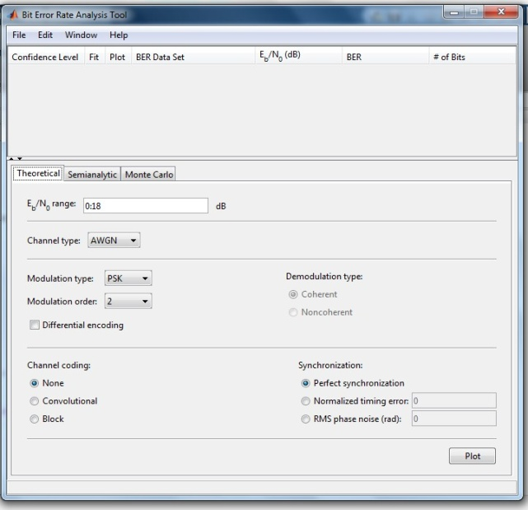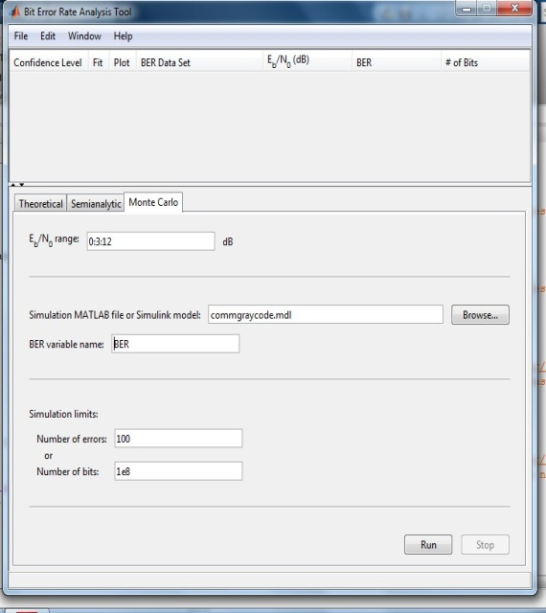

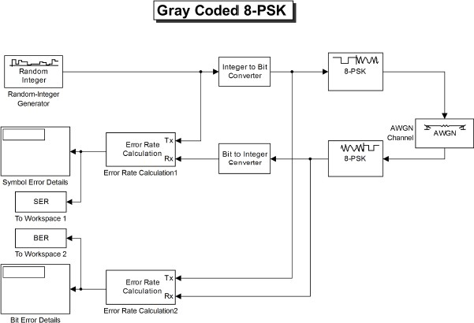

**Experiment 2**

**Aim**

Write a code to compute Bit Error Rate (BER) for different digital modulation scheme in frequency-flat and slowly varying fading channel.

# Algorithm

Step1: Generate random binary data

Step2: Construct the constellation symbols for the generated binary sequence Step3: Generate complex channel fading coefficient

Step3: Generate complex normal random variable for additive white Gaussian noise (AWGN) Step4: Add AWGN noise with the transmitted symbol

Step5: Construct maximum likelihood (ML) receiver to decode the symbol from the received signal

Step6: Compare the decoded sequence with the original sequence to estimate the number of errors

Step7: Average bit error rate (ABER) can be calculated by computing the ratio between total number of errors and total number of bits

Repeat the procedure for different modulation schemes and plot the performance curve ABER Vs SNR

clc;

close all;

clear all;

% Number of information bits

m= 10^5;

%Range of SNR values

snr_dB = [0:1:20];

for j=1:1:length(snr_dB)

n_err = 0;

n_bits = 0;

while n_err < 100

% Generate sequence of binary bits

inf_bits=round(rand(1,m));

% BPSK modulator

x=-2*(inf_bits-0.5);

% Noise variance

N0=1/10^(snr_dB(j)/10);

% Rayleigh channel fading

h=1/sqrt(2)*[randn(1,length(x)) + i*randn(1,length(x))];

% Send over Gaussian Link to the receiver

y=h.*x + sqrt(N0/2)*(randn(1,length(x))+i*randn(1,length(x)));

% decision metric

y=y./h;

% Decision making at the Receiver

est_bits=y < 0;

% Calculate Bit Errors

diff=inf_bits-est_bits;

n_err=n_err+sum(abs(diff));

n_bits=n_bits+length(inf_bits);

end

% Calculate Bit Error Rate

BER(j)=n_err/n_bits;

end

% Rayleigh Theoretical BER

snr = 10.^(snr_dB/10);

theoryBer=0.5.*(1-sqrt(snr./(snr+1)));

% AWGN Theoretical BER

theoryBerAWGN=0.5*erfc(sqrt(10.^(snr_dB/10)));

semilogy(snr_dB,theoryBer,'-','LineWidth',2);

hold on;

semilogy(snr_dB,BER,'or','LineWidth',2);

hold on;

semilogy(snr_dB,theoryBerAWGN,'blad-','LineWidth',2);

legend('Rayleigh Theoretical','Rayleigh Simulated', 'AWGN Theoretical');

axis([0 20 10^-5 0.5]);

xlabel('SNR (dB)');

ylabel('BER');

grid on;

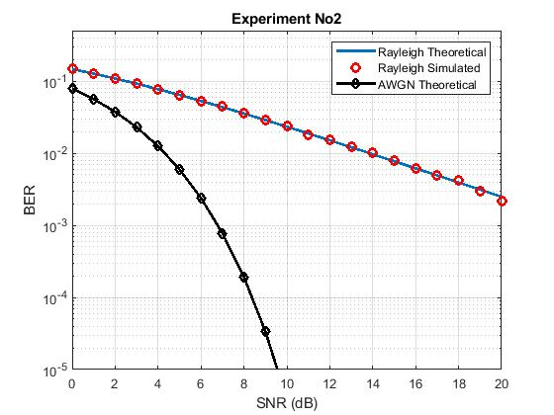

**Experiment 3**

**Aim**

Bit error rate analysis of digital communication receivers with Maximal Ratio Combining (MRC) receive diversity in frequency-flat and slowly varying fading channel.

clc;

clear all;

close all;

%%%%%%%%%%%%%%% Initialization %%%%%%%%%%%%%%%%%%%%%%%%

N=5; % Number of trials

m = 10^6; %Number of bits in each trial

ip = rand(1,m)>0.5; % Generated bits

BPSK = 2*ip-1; % Generated BPSK symbols

snr_dB = 0:1:15; % range of snr values

snr = 10.^(snr_dB/10); % snr value in the normal scale

L=2; % Number of diversity branches

% theoretical BER value for MRC combiner with 2 diversity branches

p_R_MRC = 1/2 - 1/2*(1+1./snr).^(-1/2);

ber_MRC_ana = p_R_MRC.^2.*(1+2*(1-p_R_MRC));

%%%%%%%%%% Receive MRC one by Two System %%%%%%%%%%%%%%%%%%%

n_err=zeros(1,length(snr_dB)); % Initialize the bit error counter

for p = 1:N

for q = 1:length(snr_dB)

% Generate white noise samples

No = 1/sqrt(2)*[randn(L,m) + 1j*randn(L,m)];

% Generate channel coefficient

h = 1/sqrt(2)*[randn(L,m) + 1j*randn(L,m)];

symbol = kron(ones(L,1),BPSK); % array of symbols

rec_vector = h.*symbol + 10^(-snr_dB(q)/20)*No;% received symbol

% Decision metric

dec_metric = sum(conj(h).*rec_vector,1)./sum(h.*conj(h),1);

ip_hat = real(dec_metric)>0; % Estimated symbol

n_err(q) = n_err(q)+size(find([ip- ip_hat]),2); % compare input and estimated symbols

end

end

ber_MRC_sim = n_err/(N*m);

semilogy(snr_dB,ber_MRC_ana,'-r*','LineWidth',2)

hold on;

semilogy(snr_dB,ber_MRC_sim,'ob','LineWidth',2)

legend('ber MRC sim', 'ber MRC ana');

xlabel('SNR (dB)');

ylabel('BER');

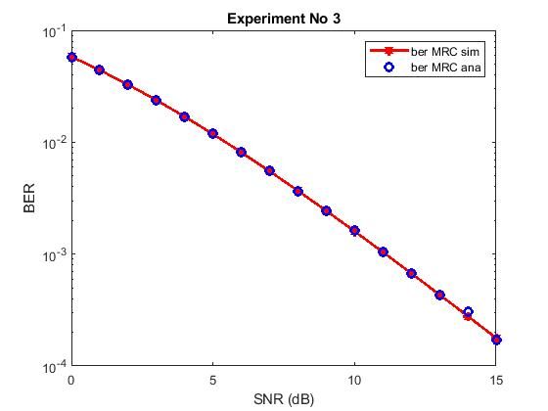

**Experiment 4**

**Aim**

Bit error rate analysis of digital communication receivers with Equal Gain Combining (EGC) receive diversity in frequency-flat and slowly varying fading channel.

clc;

close all;

clear all;

% Number of information bits

m= 10^3;

%Range of SNR values

snr_dB = [0:1:20];

for j=1:1:length(snr_dB)

n_err = 0;

n_bits = 0;

while n_err < 100

inf_bits=round(rand(1,m));

% BPSK modulator

x=-2*(inf_bits-0.5);

% Noise variance

N0=1/10^(snr_dB(j)/10);

n1 = sqrt(N0/2)*abs((randn(1,length(x)) + i*randn(1,length(x)))); %noise for the first

n2 = sqrt(N0/2)*abs((randn(1,length(x)) + i*randn(1,length(x)))); %noise for the first

h1 = sqrt(0.5)*abs((randn(1,length(x)) + i*randn(1,length(x)))); %rayleigh amplitude 1

h2 = sqrt(0.5)*abs((randn(1,length(x)) + i*randn(1,length(x)))); %rayleigh amplitude 1

%Equal Gain combining

y1 = h1.*x+n1; % Signal 1

y2 = h2.*x+n2; % Signal 2

y_equal = 0.5*(y1+y2);

% dec_metric=(norm(y_equal- h1*x-h2*x))^2;

% Decision making at the Receiver

est_bits=y_equal < 0;

% Calculate Bit Errors

diff=inf_bits-est_bits;

n_err=n_err+sum(abs(diff));

n_bits=n_bits+length(inf_bits);

end

% Calculate Bit Error Rate

BER(j)=n_err/n_bits;

end

semilogy(snr_dB,BER,'or-','LineWidth',2);

legend('Rayleigh EGC Simulated', 'Rayleigh Theoretical');

axis([0 20 10^-5 1]);

xlabel('SNR (dB)');

ylabel('BER');

grid on;

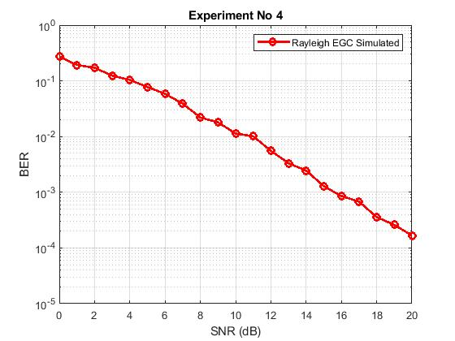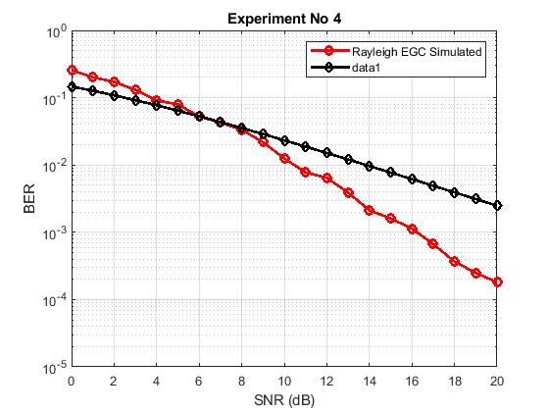

**Experiment 5**

**Aim**

To study the performance of the BPSK direct sequence spread spectrum system in AWGN channel.

clc;

close all;

clear all;

% Number of information bits

m= 10;

f_data=1; % DATA FREQUENCY

f_chip=7; % LENGTH OF CHIPSEQUENCE

fc=210; % RELATIVE CARRIER FREQUENCY

fs=fc*3; % SAMPLING FREQUENCY

N=fs/f_chip;% CODING RATE

%Range of SNR values

snr_dB = [0:2:26];

for jj=1:1:length(snr_dB) n_err = 0;

n_bits = 0;

while n_err < 100

% Generate sequence of binary bits inf_bits=round(rand(1,m));

PN_sequence=round(rand(11,1)); % GENERATION OF PN SEQUENCE

%Spread the information bits with PN sequence

j=1;

for i = 1:m

for k = j:j+f_chip-1 msg_spread(k)=inf_bits(i);

end;

msg_spread(j:(j+f_chip-1)) = xor(msg_spread(j:(j+f_chip-1))',PN_sequence(1:f_chip));

j = f_chip*i+1;

end; len_msg_spr=length(msg_spread);

% MODULATING THE SPREAD MESSAGE

% BPSK Constellation symbols

x=-2*(msg_spread-0.5);

% Noise variance N0=1/10^(snr_dB(jj)/10);

% Send over Gaussian Link to the receiver

y=x + sqrt(N0/2)*(randn(1,length(x))+i*randn(1,length(x)));

% Decision making at the Receiver msg_demod=y < 0;

% CORRELATING WITH THE PN SEQUENCE

j=1;

for i = 1:m

msg_demod(j:(j+f_chip-1)) = xor(msg_demod(j:(j+f_chip-1))',PN_sequence(1:f_chip)); j = f_chip*i+1;

end;

% DESPREADING THE RECEIVED SIGNAL

j=1;

for i = 1:m s1=0;

for k = j:j+f_chip1 s1=s1+msg_demod(k);

end;

if (s1>=6) msg_demod_rec(i)=1;

else

msg_demod_rec(i)=0;

end;

j=f_chip*i+1;

end;

% Calculate Bit Errors

diff=inf_bits-msg_demod_rec; n_err=n_err+sum(abs(diff)); n_bits=n_bits+length(inf_bits);

end

% Calculate Bit Error Rate BER(jj)=n_err/n_bits

end

semilogy(snr_dB,BER,'or-','LineWidth',2); legend('AWGN Simulated');

axis([0 26 10^-4 1]);

xlabel('SNR (dB)');

ylabel('BER'); grid on;